
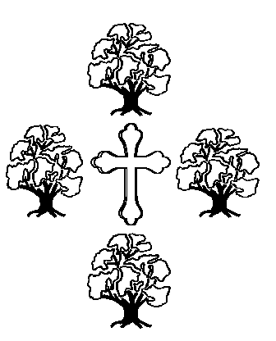


IceScout - 2014

Friday 5th - Sunday 7th December

Blackwell Court,
Agmore Rd, Blackwell,
Bromsgrove
B60 1PX

£50.00
Now you can join us at Blackwell Adventure for a fresh approach to winter camping you won't forget for 2014. Yes camping in December. All food will be provided by site staff, there are all sorts of activities laid on all weekend, including climbing, shooting, hi-ropes, G-swing and lots of indoor and outdoor crafts etc. and Friday and Saturday evening entertainment.
There are only 300 places available. This is a popular event, so please do not delay in getting your applications in. All application need to be in by asap, so please let me know by return email and bring the payment on Thursday 6th November.
Cheques payable to All Saints’ Sea Scouts

IceScout 2014

I would like to go IceScout 2014

Scout’s Name
Parent’s/Guardian’s Name
Parent’s/Guardian’s Signature
Enclosed payment £50
Cheques payable to All Saints’ Sea Scouts

